Aim: To recommend an item to the user using a collaborative filtering approach
IDE: Google Colab

Theory:
There are a lot of applications where websites collect data from their users and use that data to predict the likes and dislikes of their users. This allows them to recommend the content that they like. Recommender systems are a way of suggesting similar items and ideas to a user’s specific way of thinking.
Recommender System is different types:
- Collaborative Filtering: Collaborative Filtering recommends items based on similarity measures between users and/or items. The basic assumption behind the algorithm is that users with similar interests have common preferences.
- Content-Based Recommendation: It is supervised machine learning used to induce a classifier to discriminate between interesting and uninteresting items for the user.

In Collaborative Filtering, we tend to find similar users and recommend what similar users like. In this type of recommendation system, we don’t use the features of the item to recommend it; we classify the users into clusters of similar types and recommend each user according to the preferences of their cluster.
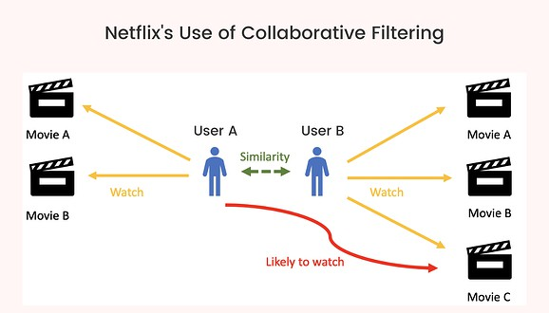

Pre Lab Exercise:
- When can you use a collaborative-based recommendation system approach?
Collaborative filtering is used when:
- User-item interaction data (ratings, likes, purchases) is available
- There are many users with similar preferences
- Item features are not available or difficult to extract
- Personalized recommendations based on user behavior are required
- The system needs to recommend items based on “people like you also liked”
- Write the advantages of a collaborative-based filtering approach
Advantages of a collaborative-based filtering approach are:
- Does not require item features
- Can recommend diverse items
- Captures user behavior and preferences effectively
- Works well with large datasets
- Can discover new interests beyond user history
- Write the disadvantages of the collaborative-based filtering approach
Disadvantages of a collaborative-based filtering approach:
- Cold start problem (new users/items)
- Requires a large amount of data
- Sparse data problem (few ratings)
- Computationally expensive
- Scalability issues

Program (Code):
import pandas as pd
import numpy as np
from sklearn.metrics.pairwise import cosine_similarity
ratings = pd.read_csv("/content/ratings.csv")
# USER-ITEM MATRIX
user_item_matrix = ratings.pivot_table(
index='userId',
columns='movieId',
values='rating'
).fillna(0)
# USER SIMILARITY
user_similarity = cosine_similarity(user_item_matrix)
user_similarity_df = pd.DataFrame(
user_similarity,
index=user_item_matrix.index,
columns=user_item_matrix.index
)
# RECOMMEND FUNCTION
def recommend_movies(user_id, top_n=5):
if user_id not in user_item_matrix.index:
return "User not found!"

# Similar users
similar_users = user_similarity_df[user_id].sort_values(ascending=False)[1:6]

# Weighted ratings
weighted_ratings = np.zeros(user_item_matrix.shape[1])

for sim_user, score in similar_users.items():
weighted_ratings += score * user_item_matrix.loc[sim_user].values

# Normalize
weighted_ratings /= similar_users.sum()

# Get unseen movies
user_rated = user_item_matrix.loc[user_id]
unseen_movies = user_rated[user_rated == 0].index

scores = list(zip(unseen_movies, weighted_ratings[user_item_matrix.columns.get_indexer(unseen_movies)]))
scores = sorted(scores, key=lambda x: x[1], reverse=True)

recommended_ids = [movie for movie, _ in scores[:top_n]]

return recommended_ids
print(recommend_movies(user_id=1))

Results:

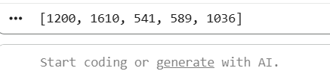

Post Lab Exercise:
- Are you satisfied with the results/ratings shown by your designed model? If yes, justify. If no, describe the probable reason for the underperformance of the system.
Yes, the results are satisfactory because the system recommends movies that are highly similar based on user ratings. It successfully identifies patterns in user preferences and suggests relevant movies.
However, some limitations were observed:
- Popular movies dominate recommendations
- New movies are not recommended (cold start problem)
- Sparse data may reduce accuracy
- Recommend top-10 “movies” using MovieLens 100K dataset
(Link: https://grouplens.org/datasets/movielens/100k/). Attach the code for output. Also, write your observation for the same.
Code:
# Install Libraries
!pip install pandas numpy scikit-learn

# Import Libraries
import pandas as pd
import numpy as np
from sklearn.metrics.pairwise import cosine_similarity

# Unzip the dataset
!unzip -o ml-100k.zip

# Load Dataset
ratings = pd.read_csv('ml-100k/u.data', sep='\t', names=['user_id','item_id','rating','timestamp'])
movies = pd.read_csv('ml-100k/u.item', sep='|', encoding='latin-1',
names=['item_id','title'] + list(range(22)), usecols=[0,1])

# Merge Data
df = pd.merge(ratings, movies, on='item_id')

# Create User-Item Matrix
user_movie_matrix = df.pivot_table(index='user_id', columns='title', values='rating')

# Fill missing values
user_movie_matrix_filled = user_movie_matrix.fillna(0)

# Compute Similarity Between Movies (Item-Based CF)
movie_similarity = cosine_similarity(user_movie_matrix_filled.T)

# Convert to DataFrame
movie_similarity_df = pd.DataFrame(movie_similarity,
index=user_movie_matrix.columns,
columns=user_movie_matrix.columns)

# Recommendation Function
def recommend_movies(movie_name, top_n=10):
if movie_name not in movie_similarity_df.columns:
return "Movie not found!"

similar_scores = movie_similarity_df[movie_name].sort_values(ascending=False)[1:top_n+1]
return similar_scores.index

# Recommendation
print("Top 10 Movies similar to 'Star Wars (1977)':\n")
print(recommend_movies('Star Wars (1977)'))
Output:
